QUESTION - 1 :



SQL:

Create a Database:
In order add data in our database, we first need to create our database. The syntax for creating database is as follows:
Create database databasename;

Example:
=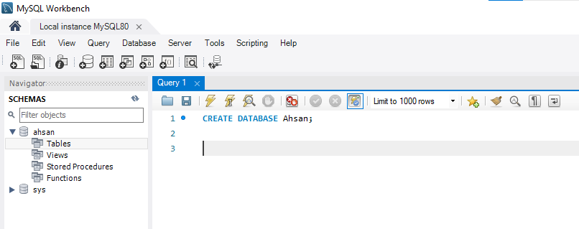

Delete a Database:
We can delete a database by using the following syntax:
Drop database databasename

Example:
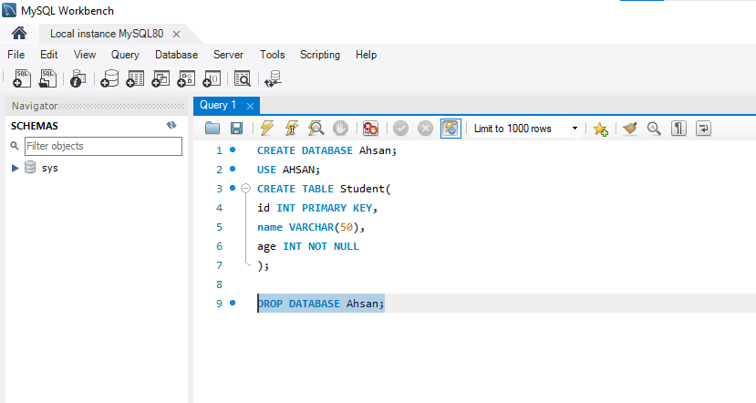

The above statement will delete all tables of Ahsan and their data.

Use a database:
To tell the DBMS about the database in which we want to create database tables or add data, we need to use the following syntax after creating our database:
Use databasename;
Example:
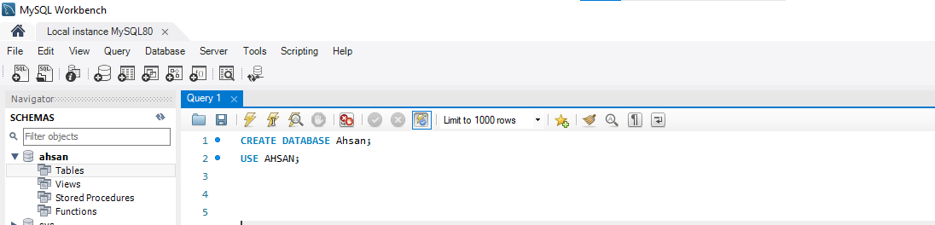

Create a Table in Database:
The CREATE TABLE statement is used to create a new table in a database.
Create Table table_name ( column1 datatype, column2 datatype, column3 datatype,
....
);

Example:

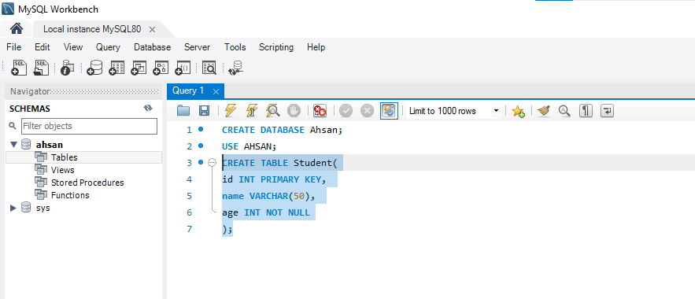

INSERT:
The INSERT command in SQL is used to add new rows to a table in a database. Below is the general syntax and some examples:
INSERT INTO table_name (column1, column2, column3, ...)
VALUES (value1, value2, value3, ...);

EXAMPLE:
